第40届国际青年物理学家锦标赛(IYPT)2027年赛题

1. Invent yourself: Pinhole sunglasses (自主发明：针孔太阳镜)
Investigate the optimal arrangement of pinholes in an opaque film to produce sunglasses that reduce light intensity and help correct short-sightedness. 研究在不透明薄膜上针孔的最优排布方式，以制作一种既能降低入射光强，又能通过针孔效应辅助矫正近视、改善视力清晰度的太阳镜。
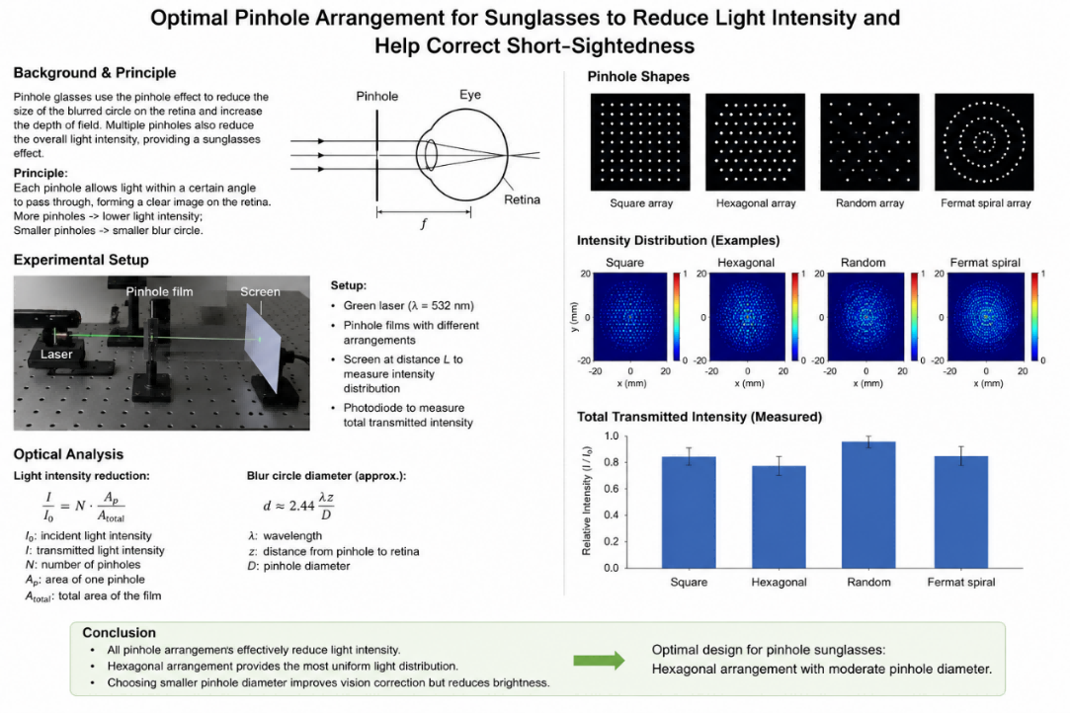
2. Disc spectrometer (光盘光谱仪)
Data tracks on optical media (e.g. CDs / Blu-ray discs) behave as high-quality reflection-diffraction gratings. When illuminated, these discs can disperse light into its spectral components. Construct a spectrometer using a digital optical disc. Optimise the design to maximise the resolving power and minimise optical aberrations. 光学存储介质(如 CD、蓝光光盘)上的数据轨道可作为高质量的反射式衍射光栅。当受到光照时，这些光盘能够将入射光色散为不同的光谱成分。利用数字光盘制作一台光谱仪，并对其结构设计进行优化，以提高光谱分辨本领并减小光学像差。
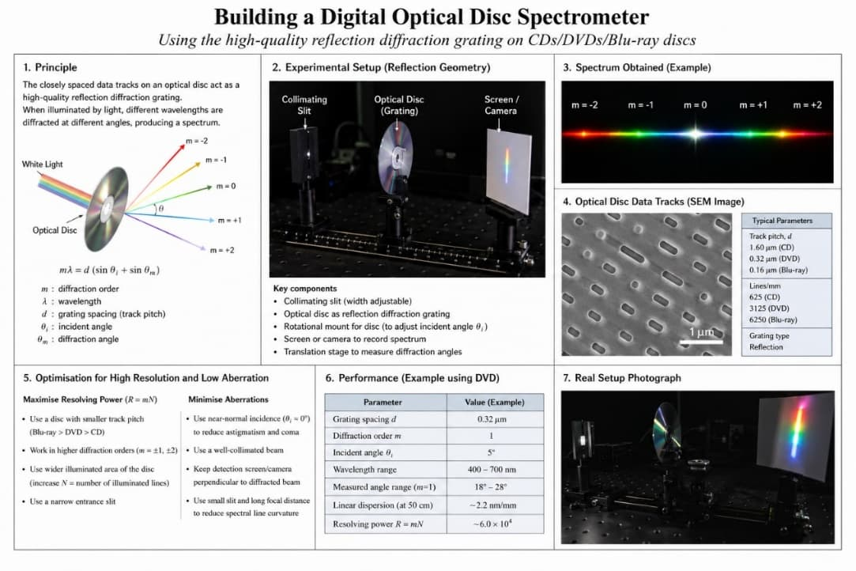
3. Snail ball (蜗牛球)
A hollow sphere contains a heavy ball and some viscous fluid. The rolling motion of such a sphere down an inclined plane is uneven and surprisingly slow. Explain and investigate this effect. 一个中空球体内部装有一个高密度小球和一定量的黏性流体。当该球体沿斜面向下滚动时，其运动呈现出明显的非匀速性，且滚动速度出乎意料地缓慢。解释并研究这一现象。
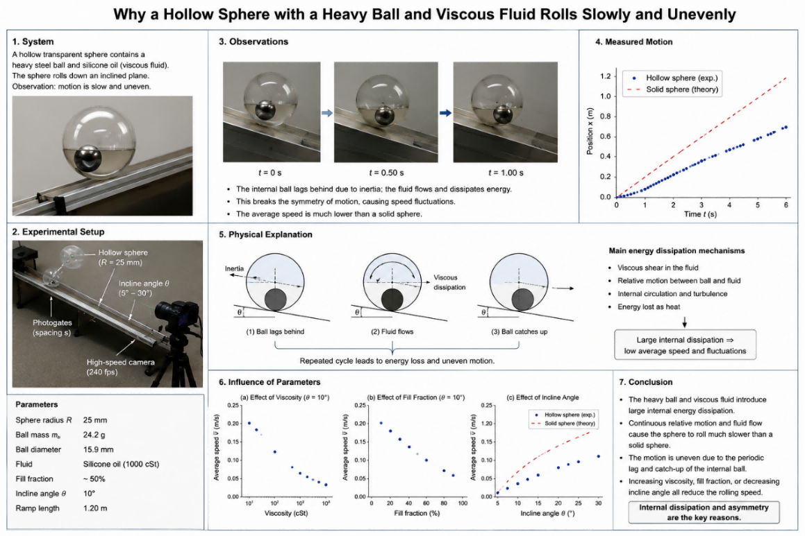
4. Singing capacitor (发声电容器)
Certain types of ceramic capacitors emit an audible sound when an alternating voltage is applied across them. Investigate the characteristics of the sound produced and how they depend on relevant parameters, such as voltage, frequency, and capacitor properties. 某些类型的陶瓷电容器在其两端施加交流电压时会产生可听声。研究所产生声音的特性，并分析其对相关参数的依赖关系，例如外加电压、驱动频率以及电容器自身的结构与材料特性。
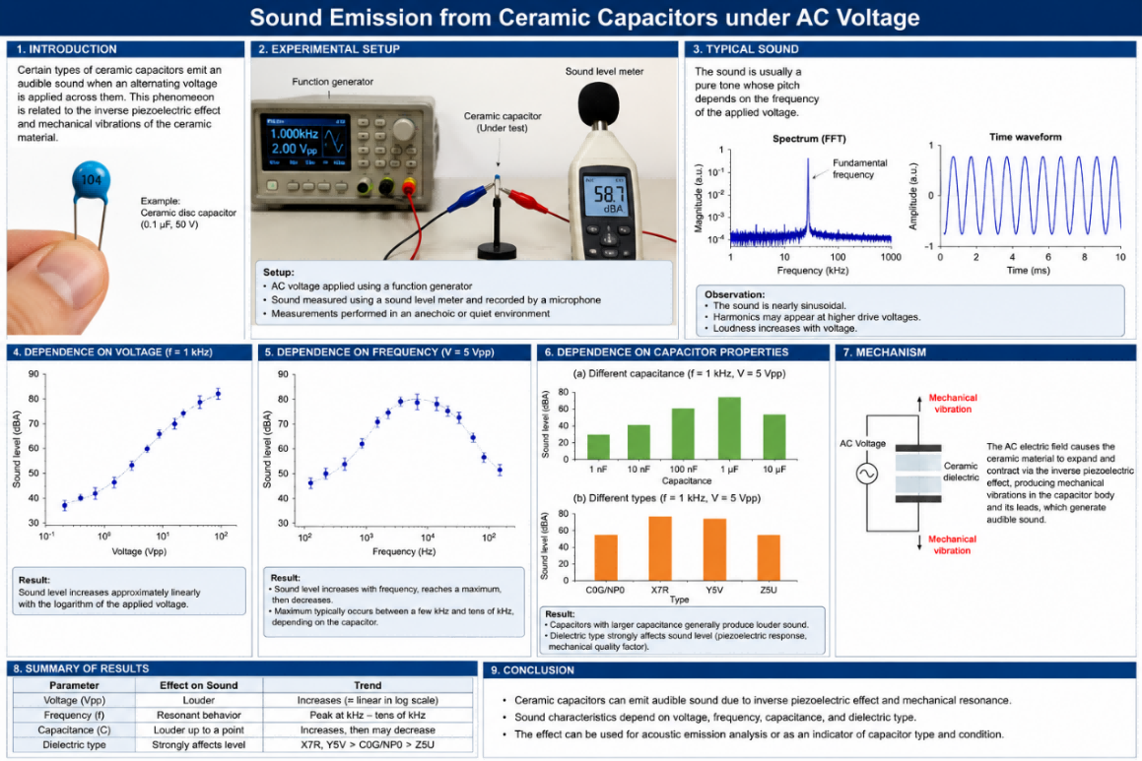
5. Y-shaped pendulum (Y形摆)
Construct a Bowditch pendulum (a pendulum whose strings form a “Y” shape). Investigate how the Lissajous patterns generated by the bob depend on the relevant parameters. 搭建一个鲍迪奇摆(其悬线呈“Y”形结构的摆)。研究摆球运动所形成的李萨如图形如何随相关物理参数的变化而变化。
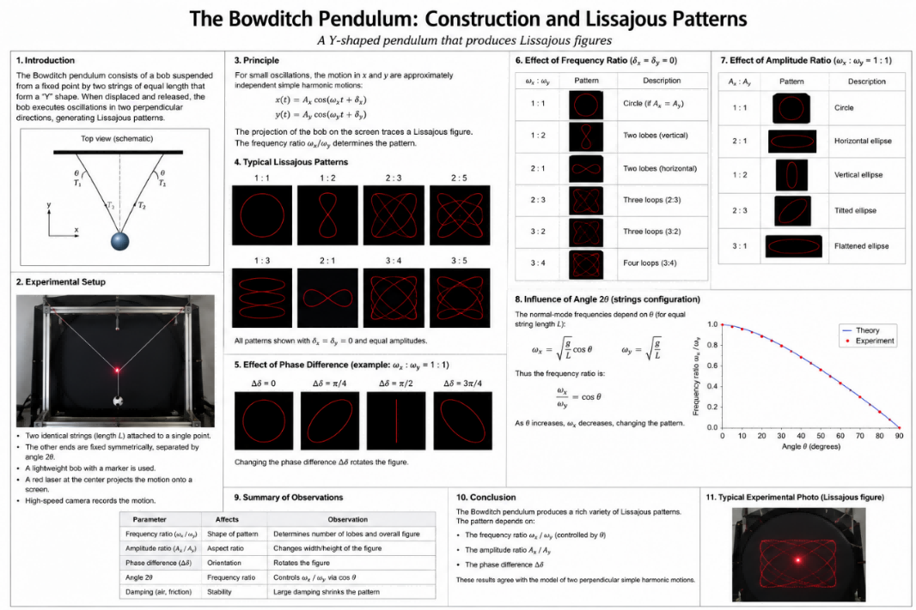
6. Seeing sound (声音的可视化)
A thin rubber membrane is stretched over a circular frame and driven into vibration by a loudspeaker. A small mirror is attached to the membrane, and a laser beam is reflected off it onto a distant screen. Under certain conditions, the laser spot traces out complex, steady, or evolving geometric patterns. Investigate the relationship between the driving parameters, the membrane’s properties, and the resulting light patterns. 将一层薄橡胶膜张紧并固定在圆形框架上，利用扬声器驱动其振动。在膜面上安装一块小型反射镜，使激光束经反射后投射到远处的屏幕上。在特定条件下，激光光斑会描绘出复杂的、稳定或随时间演化的几何图样。研究驱动参数、振膜的物理性质与所形成光学图样之间的关系。
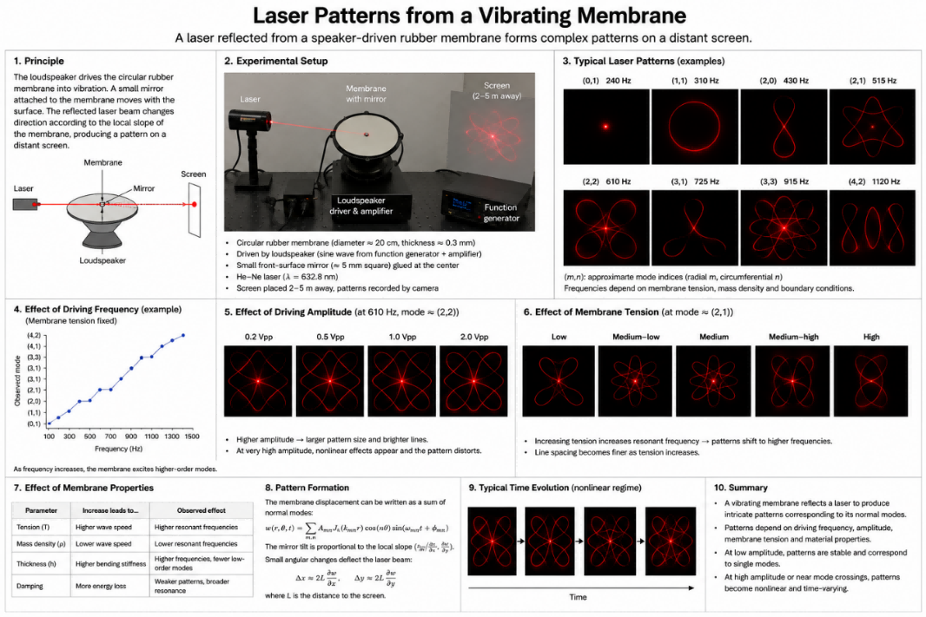
7. Sinking funnel (下沉漏斗)
When a long-stemmed and sufficiently heavy funnel is released vertically into water with the stem pointing downward, it undergoes a series of damped vertical oscillations while gradually sinking. Investigate the motion and stability of the sinking funnel and the conditions under which the funnel tips over. 将一个具有长管颈且质量足够大的漏斗，以管颈竖直向下的姿态释放入水后，漏斗会在逐渐下沉的同时产生一系列受阻尼的竖直振荡。研究漏斗下沉过程中的运动特性与姿态稳定性，并确定其发生倾覆的条件。
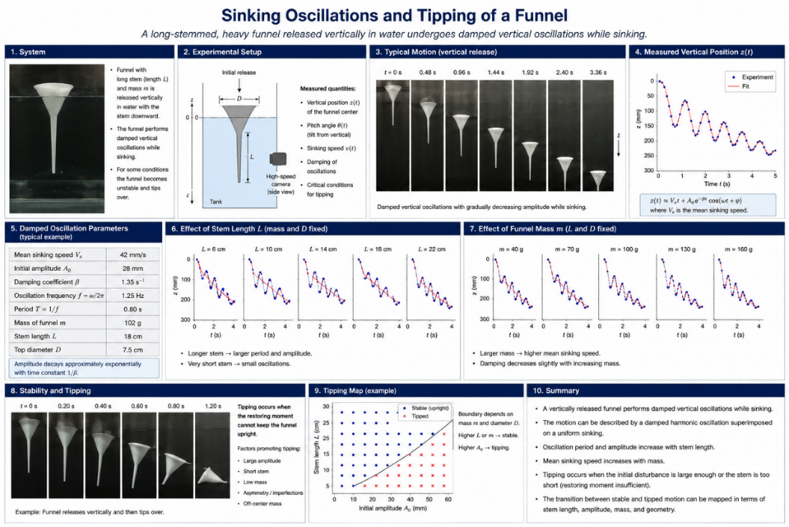
8. Upward-driven disc (向上驱动的圆盘)
A circular disc is suspended from the point where it is sandwiched between two wheels, making it free to oscillate as a pendulum. One of the wheels is driven by a motor and thus exerts an upward driving force on the disc. Investigate the motion of the disc. 一个圆盘由其夹持在两个滚轮之间的接触点悬挂，从而能够像摆一样自由振荡。其中一个滚轮由电动机驱动，并因此对圆盘施加向上的驱动力。研究该圆盘的运动特性。
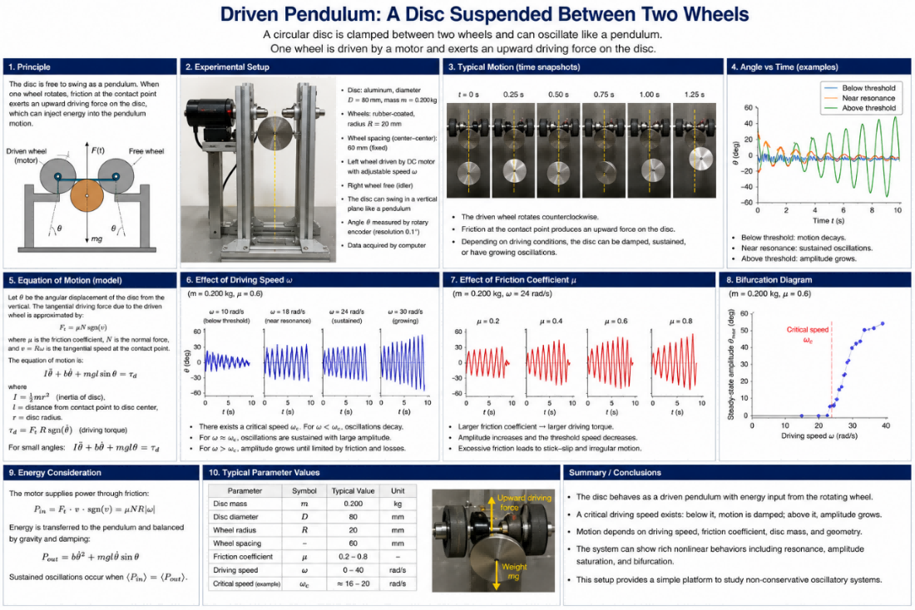
9. Photographic bokeh (摄影散景)
Bokeh is an effect observed in photographs that show objects at different distances from the camera and have both sharp and out-of-focus areas. If a slit is placed in front of the lens of the camera, the image may have unusual anisotropic distortions in out-of-focus areas, while in-focus areas remain undistorted and sharp. Investigate how the properties and sharpness of resulting images depend on relevant parameters. 散景是摄影中常见的一种成像现象，通常出现在画面中存在不同物距的物体、因而同时包含清晰区域与离焦区域的情况下。若在相机镜头前放置一条狭缝，离焦区域的图像可能出现异常的各向异性形变，而合焦区域仍保持清晰且基本不发生畸变。研究所得图像的形态特征与清晰度如何依赖于相关参数。
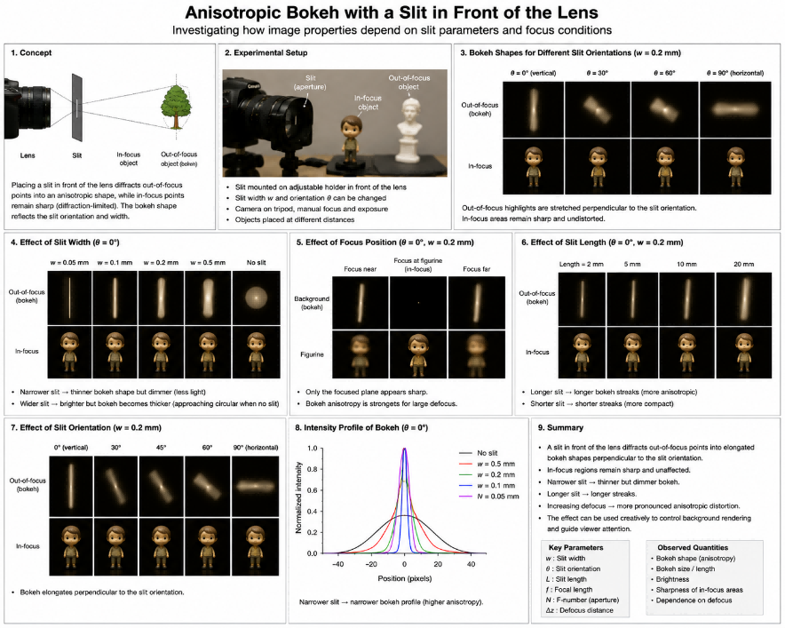
10. Air vortex (空气涡旋)
Place a small rod-shaped magnet on the bottom of a vessel filled with liquid and set it into rotation using a magnetic stirrer. Above a certain rotation speed, a thin air channel forms, extending from the liquid surface down to the rotating magnet itself. Investigate and explain this phenomenon. 在盛有液体的容器底部放置一根小型棒状磁体，并利用磁力搅拌器使其旋转。当转速超过某一临界值时，液体中会形成一条细长的空气通道，自自由液面一直延伸至旋转磁体附近。研究并解释这一现象。
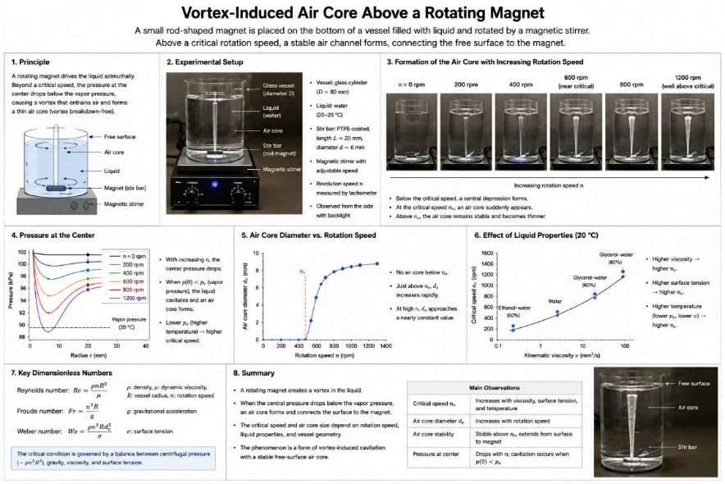
11. Sound isolation (隔声)
The sound isolation of a room may become breached if the door is not shut properly, even if the gap is negligibly small. Investigate how the shape and size of a small opening affect the transmission of sound. 即使门缝极其微小，若房门未完全关闭，房间的隔声性能仍可能显著下降。研究小孔隙的形状与尺寸对声波透射特性的影响。
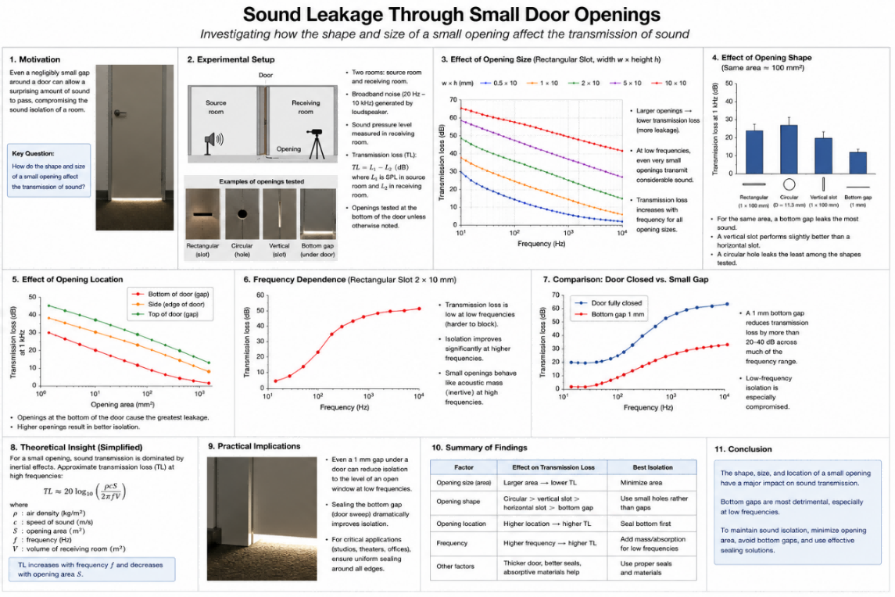
12. Dotted line trick (点线效应)
Under certain conditions, when a piece of chalk is dragged across a blackboard, the resulting trace is not a continuous line but a periodic sequence of dots, even though the motion is uninterrupted. This can happen with other writing materials and surfaces. Investigate the physical parameters that govern this phenomenon. 在特定条件下，当粉笔在黑板表面连续划动时，留下的痕迹并非连续线条，而是一系列具有周期性的离散点状印迹。类似现象也可能出现在其他书写材料与表面组合中。研究支配该现象的相关物理参数。
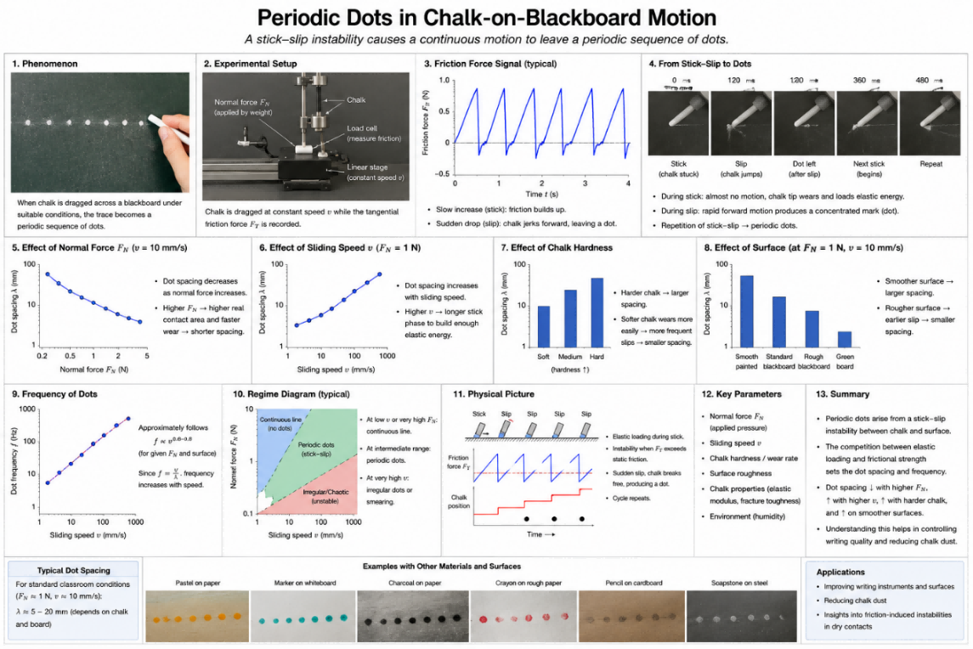
13. Vortex pendulum (涡激摆)
A pendulum with a vertically oriented cylindrical bob is suspended above a channel of flowing water. When the bob is partially submerged, the flow may cause the pendulum to oscillate in a direction perpendicular to the flow. Explain this phenomenon and determine how it depends on relevant parameters. 一个摆的摆锤为竖直放置的圆柱体，并悬置于水流通道上方。当摆锤部分浸没于流动的水中时，水流可能诱发摆锤沿垂直于来流方向的横向振荡。解释这一现象，并研究其对相关物理参数的依赖关系。
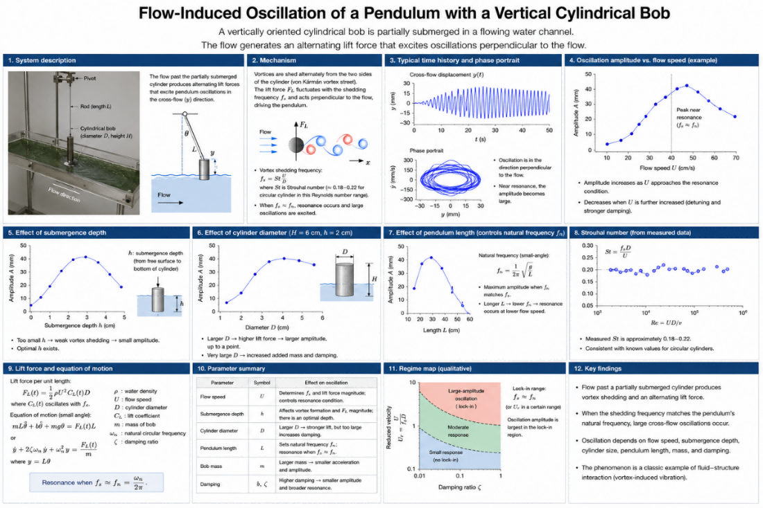
14. Non-Newtonian worms (非牛顿流体“蠕虫”)
If a dilatant non-Newtonian fluid (e.g. a suspension of water and cornflour) is vibrated vertically in a reservoir. When certain conditions are met, wormlike structures that rise from the surface may form. Explain and investigate this phenomenon. 将剪切增稠型非牛顿流体(例如水与玉米淀粉形成的悬浮液)置于容器中并施加竖直振动。当满足一定条件时，流体表面可能形成向上突起的蠕虫状结构。解释并研究这一现象。
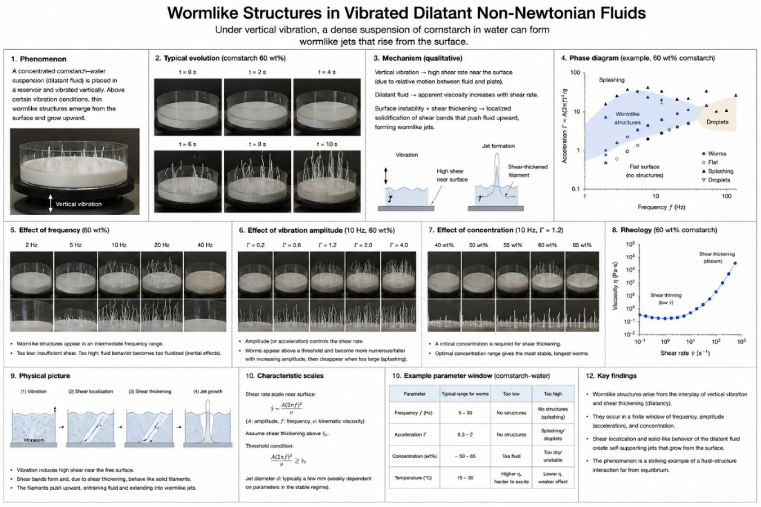
15. Cold drink (饮料冷却)
A can or bottle of drink at room temperature can be cooled in a cooler containing ice. Adding salt and alcohol to the ice can increase the rate of cooling and affect the drink’s final temperature. Investigate how the relevant parameters affect the lowest achievable temperature and the maximum cooling rate. 将处于室温的罐装或瓶装饮料置于装有冰的保冷容器中，可使其降温。向冰中加入盐和酒精能够提高饮料的冷却速率，并影响其最终温度。研究相关参数对最低可达温度和最大冷却速率的影响。
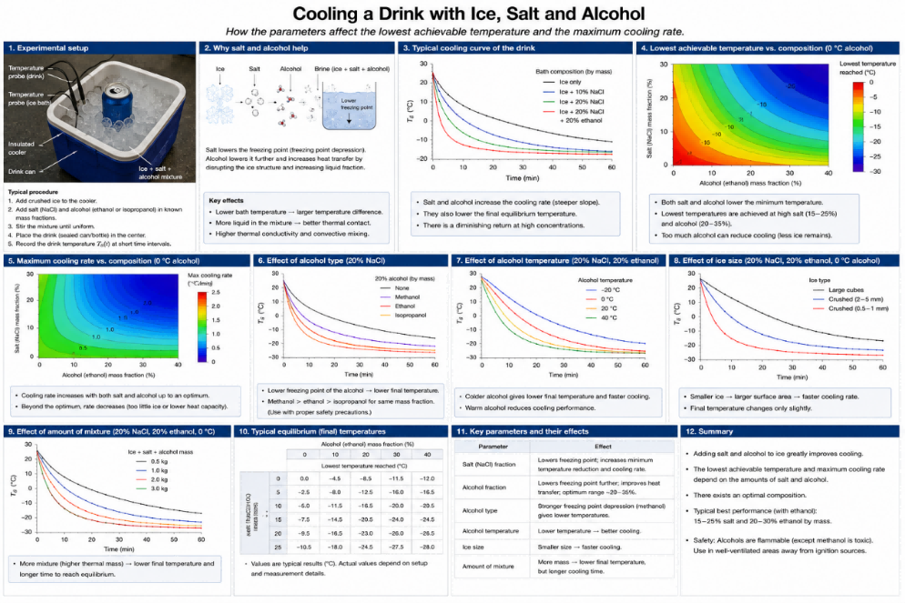
16. Magnetic carousel (磁力转盘)
Several neodymium magnets are attached to a horizontal disc, with adjacent magnets oriented in opposite directions. A fixed non-magnetic plate is placed horizontally above the disc. When the disc rotates about its vertical axis and a steel ball is placed on the plate, the ball may move either in the same direction as, or opposite to, the rotation of the disc. Investigate this phenomenon and determine how the motion depends on relevant parameters. 在一个水平圆盘上安装若干钕磁体，并使相邻磁体的磁化方向彼此相反。在圆盘上方水平放置一块固定的非磁性薄板。当圆盘绕其竖直轴旋转，并在薄板上放置一颗钢球时，钢球可能沿圆盘旋转方向运动，也可能沿相反方向运动。研究这一现象，并确定钢球的运动如何依赖于相关物理参数。
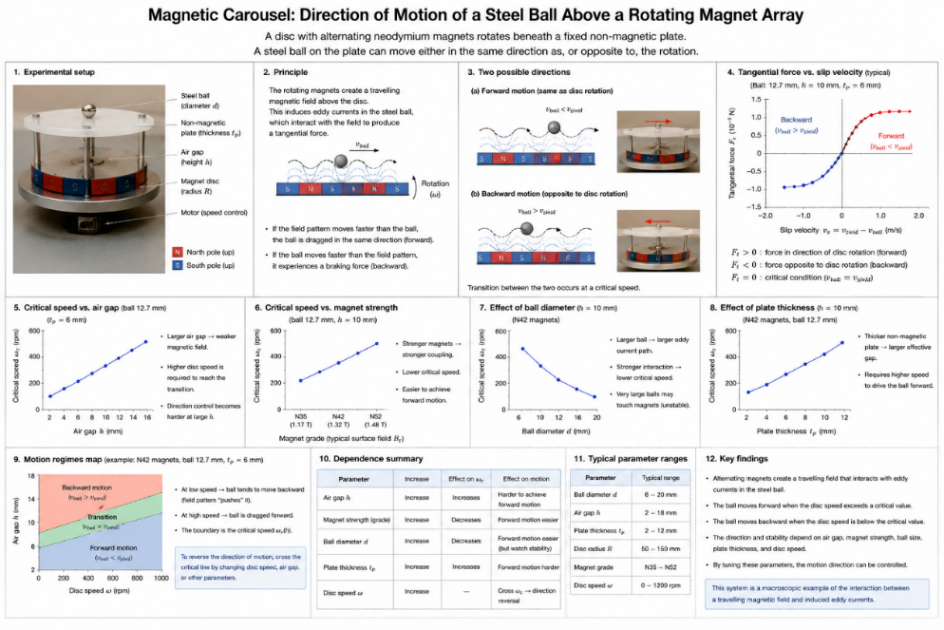
17. Falling book cover (下落的书封)
A book is placed horizontally, and the partially open cover is allowed to fall. Investigate the motion of the falling book cover. 将一本书水平放置，使其部分张开的封面自由下落。研究书籍封面在下落过程中的运动特性。
